ELECTROCHEMISTRY

Electrochemistry is a branch of chemistry that studies chemical reactions which take place in a solution at the interface of an electron conductor (a metal or a semiconductor) and an ionic conductor (the electrolyte), and which involve electron transfer between the electrode and the electrolyte or species in solution.

If a chemical reaction is driven by an external applied voltage, as in electrolysis, or if a voltage is created by a chemical reaction as in a battery, it is an electrochemical reaction. In contrast, chemical reactions where electrons are transferred between molecules are called oxidation-reduction (redox) reactions.

Electrolytes:

Electrolytes are electrovalent substances that form ions in solution which conduct an electric current.

Electrolysis:

The phenomenon of decomposition of an electrolyte by passing electric current through its solution is termed electrolysis. In chemistry and manufacturing, electrolysis is a method of using a direct electric current (DC) to drive an otherwise non-spontaneous chemical reaction. Electrolysis is commercially important in the separation and purification of elements from naturally occurring sources such as ores using an electrolytic cell. It is also used for the protection and beautification of metallic materials which popularly known as electroplating.

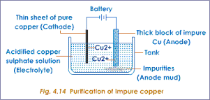
Electrical Units:

Coulomb- a unit quantity of electricity
Ampere- a unit rate of flow of electricity
Ohm- a unit of electrical resistance
Volt- a unit of electromotive force

Fig: Mechanism of Electrolysis

Conductance of electrolytes:

The power of electrolytes to conduct electrical currents is termed conductivity or conductance of electrolytes. It is reciprocal of the resistance (R) and denoted by C. So, C=R⁻¹. The unit of conductance is ohm⁻¹ or mho or Siemens (S).

Specific Conductance (κ, kappa):

The conductance of one centimeter cube of a solution of an electrolyte is called ‘specific conductance’.

Unit: κ = 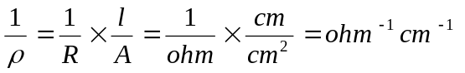[ 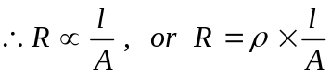 ]
Equivalent Conductance (λ, lambda):

The conductance of an electrolyte obtained by dissolving one gram-equivalent of it in V cc of water is known as ‘equivalent conductance’.

Mathematically, λ = κ × V

Unit: λ = κ × V = 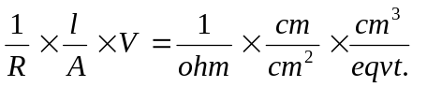

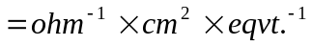

Kohlrausch’s Law (1875):

“ The equivalent conductance of an electrolyte at infinite dilution* (λ∝) is equal to the sum of the equivalent conductances of the component ions”.

* when the mobility of the ions in solution is almost zero.

Mathematically, we can write-

λ∝ = λ_{a} + λ_{c}

where λ_{a} is the equivalent conductance of the anion and λ_{c} is that of cation.

For Example, the equivalent conductance of NaCl at infinite dilution at 25°C is 126.45. The equivalent conductances of Na⁺ and Cl⁻ ions are 50.11 ohm⁻¹ and 76.34 ohm⁻¹ respectively. Thus,

λ∝ (NaCl) = λ∝ (Na⁺) + λ∝ (Cl⁻),

or 126.45 = 50.11 + 76.34

This is in good agreement with Kohlrausch’s law.

Example-1: Calculate the equivalent conductance of NH₄OH at infinite dilution at 20°C. Given: λ∝ (NH₄Cl) = 130, λ∝ (OH⁻) = 174 and λ∝ (Cl⁻) = 66.

Solution: Applying the Kohlrausch’s law,

λ∝ (NH₄OH) = λ∝ (NH₄Cl) + λ∝ (OH⁻) - λ∝ (Cl⁻)

=130 + 174 – 66 = 238 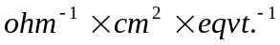 Ans.

Conductometric Titrations:

“Titrations in which conductance measurements are made use of in determining the end-point of acid-alkali reactions, some displacement reactions or precipitation reactions are called conductometric titrations”.

- Titration of a strong acid against a strong base.

HCl → H⁺ + Cl⁻
H⁺ + Cl⁻ + Na⁺ + OH⁻ → Na⁺ + Cl⁻ + H₂O
Conductance
Vol. of base
End-point
Figure: Conductometric titration curve for
HCl and NaOH

  - Before addition of alkali, conductance of the solution is due to presence of H⁺ and Cl⁻ ions.
  - H⁺ posses greatest mobility of any ion, hence the conductance is greater.
  - After addition of NaOH, H⁺ is removed by OH⁻ forming feebly (weakly) ionized H₂O molecules and their (H⁺) place is taken by slow moving Na⁺ ions.
  - The conductance of the solution decreases with further addition of alkali and reach minimum (end-point).
  - With further addition of NaOH solution, conductance increases since OH⁻ ions do not consume in the reaction in the form of H₂O molecule.

- Titration of a weak acid against a strong base.

CH₃COOH → CH₃COO⁻ + H⁺
CH₃COOH + Na⁺ + OH⁻ → CH₃COO⁻ + Na⁺ + H₂O

Conductance
Vol. of base
End-point
Figure: Conductometric titration curve for
CH₃COOH and NaOH

- Initial conductance is low because of the poor dissociation of the weak acid.
- Sodium acetate formed; at first suppress the ionization due to common-ion-effect.
- Conductance begins to increase with the further addition of alkali.

- Titration of a strong acid against a weak base.

Conductance
Vol. of base
End-point
Figure: Conductometric titration curve for
HCl and NH₄OH

- In this case, the conductance of the solution will first decrease due to the fixing up of the fast moving H⁺ ions and their replacement by slow moving NH₄⁺.

- Titration of a weak acid against a weak base.

- The initial conductance of the solution is low due to poor dissociation of the weak acid.
- It starts increasing as the salt CH₃COONH₄ is formed.
- After the equivalence point, the conductivity remains almost constant because the free base NH₄OH is a weak electrolyte.

Conductance
Vol. of base
End-point
Figure: Conductometric titration curve for
CH₃COOH and NH₄OH

This conductometric method is suitable as such titration give a quite sharp end-point.

Advantages of conductometric titrations over volumetric titrations:

- coloured solutions where no indicator is found to work satisfactorily can be successfully titrated by this method.

- The method is useful for the titration of weak acids against weak bases which do not give a sharp change of colour with indicators in ordinary volumetric analysis.

- More accurate results are obtained because the end-point is determined graphically.

Precautions:

  - Temperature should be kept constant throughout the experiment.

  - The titrant (standard solution in burette) should be 10 times stronger so that the volume change is as little as possible.

Differences between conductometric titrations and volumetric titrations:

Conductometric titrations | Volumetric titrations
- Conductance measurements are done to check end-points.  - Titration can be carried out even with coloured solution.  - Accurate results are obtained.  - End-points are determined graphically.  - Successful even in weak acids and bases. | - Volume measurements are done to check end-points.  - Titration fails in coloured solution as suitable indicators are not available sometimes.  - Results are not so accurate.  - End-points are determined by change of colour of indicator.  - Not successful in weak acids and bases.

Electrolytic and Electronic Conductors:

Electrolytic conductors | Electronic conductors  (or metallic conductors)
- Electrolytic conduction takes place by actual movement of ions, positive and negative towards the opposite electrodes.  - This is attended with chemical changes at the electrode.  - Electrolytic conductor becomes more conducting at higher temperatures.  - Fused salts of electrovalent compounds, solution of electrovalent and some covalent compounds in water and in a few other polar solvents are examples of these conductors. | - Electronic conduction takes place without any transfer of material during the passage of the current.  - No chemical change takes place during electronic conduction.  - The resistance of these conductors increases at higher temperature.  - Metals in general and alloys are classed as electronic conductor. Carbon a non-metal and certain solid salts (cadmium sulphide, cupric sulphide etc.) are also belong to this group.

Battery Chemistry

A battery is a device that converts chemical energy into electrical energy. This is done by means of an electro-chemical oxidation-reduction reaction of its active materials. This process involves the transfer of electrons from one material to another through an electric circuit.

Types of Batteries

They are two types of batteries- Primary batteries and Secondary or storage batteries. Primary batteries can provide only one continuous discharge, cannot be reused and re-charged. They are used as a source of dc power for everyday items such as flashlights and transistor radios.
A secondary or storage battery is made of several chemical and elemental materials. These materials change during charging and discharging and this change is reversible. After the battery has discharged, it is brought back to a charged state, by causing the current to flow back through the battery in the opposite direction. The electrodes are thus returned to approx. their original state. The most common battery of this type is lead- (sulfuric) acid battery. Secondary batteries are used as a source of dc power when the battery is the main source of power and many discharge and charge cycles are required, such as electrical vehicles, mine locomotives, submarines, or standby power required such as telephone exchange and emergency lighting. They are often used to supply large, short time repetitive power requirements such as car and airplane batteries. They are also used for load leveling of an electric power supply network.

The discharge reaction can be written for a primary battery as follows:

Anode (Oxidation): Zn (s) → Zn²⁺ + 2e⁻;
Cathode (Reduction): 2NH₄⁺ + 2e⁻ → 2NH₃ (g) + 2 H₂ (g)
Cell Reaction: Zn (s) │Zn²⁺ (aq) ││ 2NH₄⁺ (aq), [2NH₃ (aq) + H₂ (g)] │ C (gr); E = 1.5V

Then MnO₂ prevents H₂ from collecting on graphite rod:
H₂ (g) + 2MnO₂ (s) → 2MnO(OH)(s)

At the anode, NH₃ combines with Zn²⁺ to remove it from the reaction:
Zn²⁺ + 4NH₃ → Zn(NH₃)₄²⁺

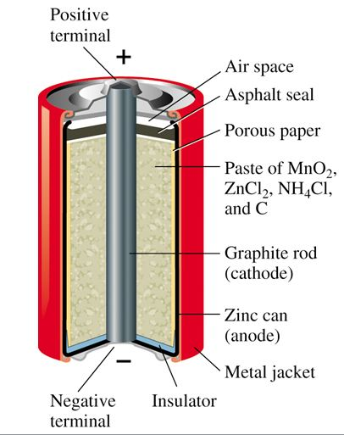
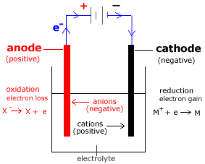

The discharge and charge reactions can be written for secondary batteries as follows:

Anode (Oxidation): Pb (s) + H₂SO₄ (aq) → PbSO₄ (s) + 2e⁻ + 2H⁺ (aq)
Cathode (Reduction): PbO₂ (s) + 2H⁺ + H₂SO₄ (aq) + 2e⁻ → PbSO₄ (s) + 2H₂O (l)
→ (discharging)
Overall Reaction: PbO₂ (s) + Pb (s) + 2H₂SO₄ (aq) = 2PbSO₄ (s) + 2H₂O (l)
← (charging)

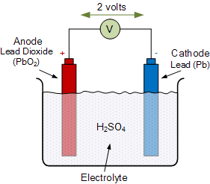
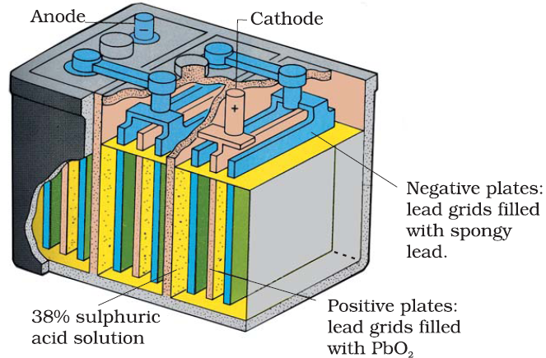

Repeated charging causes hydrolysis of H₂O into H₂ and O₂, so distilled water is added sometimes to keep H₂SO₄ concentration constant.

LITHIUM ION BATTERY

A lithium-ion battery or Li-ion battery is a type of rechargeable battery composed of cells in which lithium ions move from the negative electrode through an electrolyte to the positive electrode during discharge and back when charging.
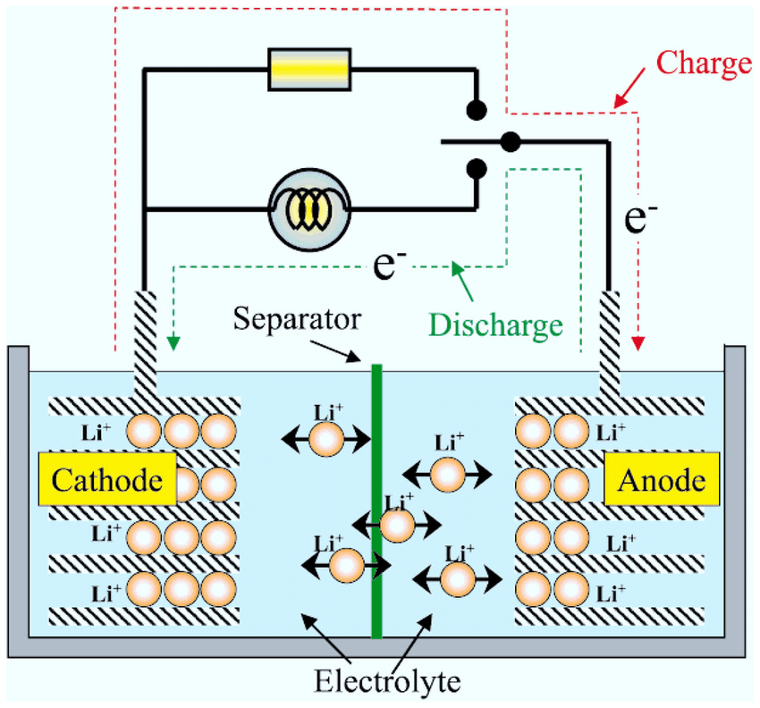

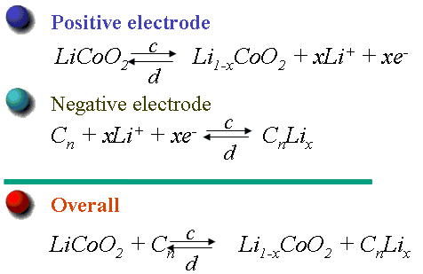

Rechargable litium ion cells are the key components of today’s information rich mobile society. Lithium ion battery has highest volumetric and gravimetric energy density (smaller and lighter) compare to other battery technologies. Current lithium ion technology is based on a layered LiCoO2 cathode and graphite anode.

PHOTOLITHOGRAPHY

Lithography is a method of printing from a stone or a metal plate with a smooth surface originally based on the immiscibility of oil and water. It was invented in 1796 by German author and actor Alois Senefelder as a cheap method of publishing theatrical works. Lithography can be used to print text or artwork onto paper or other suitable material. In modern lithography, the image is made of a polymer coating applied to a flexible aluminum plate. The image can be printed directly from the plate, or it can be offset, by transferring the image onto a flexible sheet (rubber) for printing and publication.

The related term "photolithography" refers to when photographic images are used in lithographic printing. It plays an important role in the fabrication and mass production of integrated circuits (IC) in the microelectronics industry. The photolithography process involves light exposure through a mask to project the image of a circuit, much like a negative image in standard photography. This process hardens a photo-resistive layer on the printed circuit board (PCB) or silicon wafer (of microprocessors). The hardened areas stay behind in the form of circuit paths of PCBs. Unexposed areas are then dissolved away by a solution bath, such as an acid in wet methods or plasma-like oxygen ions in dry methods.

Silicon wafers are solid pieces of nearly-pure (99.99%) silicon. Photoresist compounds are used to create a mask on the surface of a silicon wafer. Photoresists have three major components, a solvent, resin, and sensitizer (or photoactive compound). The compound is applied to the silicon wafer in liquid form and polymerization is controlled through exposure to light. A common method to increase adhesion of photoresist on the silicon wafer surface is to treat the wafer with Hexamethyldisilazane, C₆H₁₉NSi₂ (HMDS).

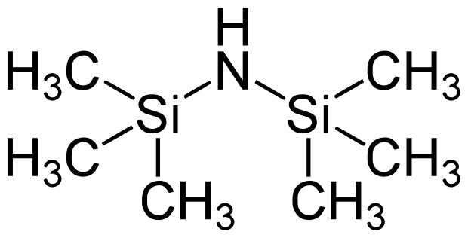

The general sequence of processing steps for a typical photolithography process is as follows: substrate preparation, photoresist spin coat, prebake, exposure, post-exposure bake, development, and postbake. A resist strip is the final operation in the lithographic process, after the resist pattern has been transferred into the underlying layer. This sequence is shown diagrammatically in Figure 1:
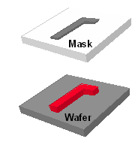
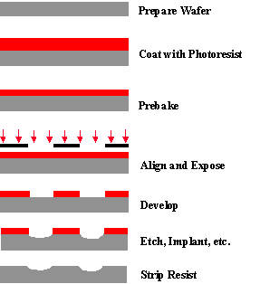

Figure 1. Example of a typical sequence of lithographic processing steps (with no post-exposure bake in this case), illustrated for a positive resist.

